Divorce or Dissolution of a Civil Partnership

Introduction

If you get divorced or your civil partnership is dissolved, it may impact on your pension in the Local Government Pension Scheme (LGPS). You will be asked to declare your financial interests, which will include your pension under the LGPS. The Court will then consider this pension when deciding any settlement to your ex-spouse or ex-civil partner.

You and your ex-spouse / civil partner will therefore need to tell the Court the value of any pensions you may have (other than the State Pension). You can then agree how any pensions should be split and the Court will issue either a Pension Sharing Order or Pension Earmarking Order to confirm the settlement.

What is a Pension Sharing Order?

A Pension Sharing Order is an arrangement that divides your pension when you get divorced or your civil partnership is dissolved, so that your ex-spouse or ex-civil partner is given part of your pension.

What is a Pension Earmarking Order?

An Earmarking Order is an arrangement where part of one person’s pension is paid to the ex-spouse or ex-civil partner when that pension is paid. This can either be a lump sum amount or part of your annual pension. This payment will then stop when you die or if your ex-spouse or ex-civil partner remarries or enters a new civil partnership.

What if you are already being paid a LGPS pension?

If you are already being paid your LGPS pension, your ex-spouse or ex-civil partner will only be given a share of your annual pension and will not have the choice of a tax-free cash lump sum.

What is the process?

You will need certain information about your LGPS benefits as part of the divorce proceedings or dissolution of a civil partnership. This information includes an estimate of the Cash Equivalent Value (CEV) of your pension.

The following chart shows how the process will work.

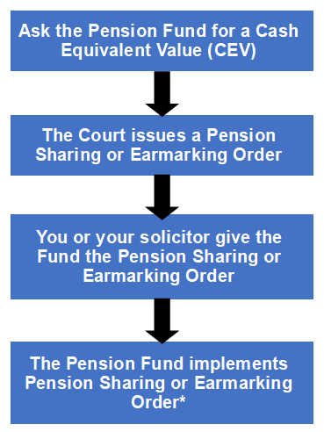 | The Pension Fund will provide you with a CEV within 3 months of the date of your request, or sooner if for a Court date. If you have already received a free CEV within 12 months of the date of request, there may be a charge.
 | The Pension Sharing or Earmarking Order will state the proportion of pension to be shared or earmarked. A Pension Sharing Order will also show the date it is effective from.
 | You and your ex-spouse or civil partner will need to pay the charge for implementing the Order before the Pension Fund can do so.
*You can find out more information about the charges for supplying information for or implementing a Court Order from the Pension Fund.

What happens to your LGPS pension once your divorce or dissolution has been completed?

- Your ex-spouse or civil partner will no longer be entitled to a survivor’s pension if you die before them.

- A survivor’s pension paid to any eligible children when you die will not be affected.

- Any lump sum death grant to be paid when you die will be paid to whoever you have stated on your Expression of Wish Form. If you need to change this once your divorce or dissolution has been completed, you should complete a new Expression of Wish form (unless the court has issued an Earmarking Order which states all, or part of the lump sum death grant should be paid to your ex-partner or ex-civil partner if you die before them).

- Your ex-spouse or ex-civil partner may be awarded a pension credit in the LGPS, which will be separate to your pension.

What if you re-marry or enter a new civil partnership?

If a Pension Sharing Order is implemented against your LGPS pension, any survivors pension paid to a spouse, civil partner or eligible co-habiting partner will also be reduced, should you die before them.

You may wish to complete a new Expression of Wish form to change any previous beneficiaries at this point. You can go to the Pension Fund website to download this form.

What happens to your ex-spouse / civil partner’s pension credit?

After the implementation of any Pension Sharing or Earmarking Order, your ex-spouse or ex-civil partner will be or may be awarded a pension credit. This is a pension awarded specifically to them in the LGPS, in line with the debit to your pension. Note that it is then separate to your benefits.

They will be able to choose to:

- Take payment of their pension credit from age 55 with reductions based on current LGPS rules; or
- Take payment of their pension credit at their Normal Pension Age (NPA), which under current LGPS rules, is the same as their State Pension Age but could change in the future.

The pension credit may also be paid earlier on the grounds of ill health or if your ex-spouse or ex-civil partner choose to transfer their pension credit to another pension arrangement.

When can you expect to receive the CEV of your pension rights?

Once you have made the request, you should expect to receive the CEV within 3 months. There may be a delay as information is sometimes required from Her Majesty's Revenue & Customs (HMRC) and from your Employer. The Pension Fund can only calculate the CEV upon receipt of this information.

Please be aware that there may be a charge for providing you with a CEV. This will be confirmed by the Pension Fund.

Where can you find more Information?

This factsheet gives general guidance only, if you need further information, please contact the Pension Fund.

Disclaimer

The Pension Fund is unable to provide any financial or legal advice. After reading this factsheet, you may want to seek independent financial advice or legal advice from a solicitor.

These bodies may be able to help you:

Unbiased: https://unbiased.co.uk/
Money Advice Service: https://www.moneyadviceservice.org.uk/en/articles/choosing-a-financial-adviser

