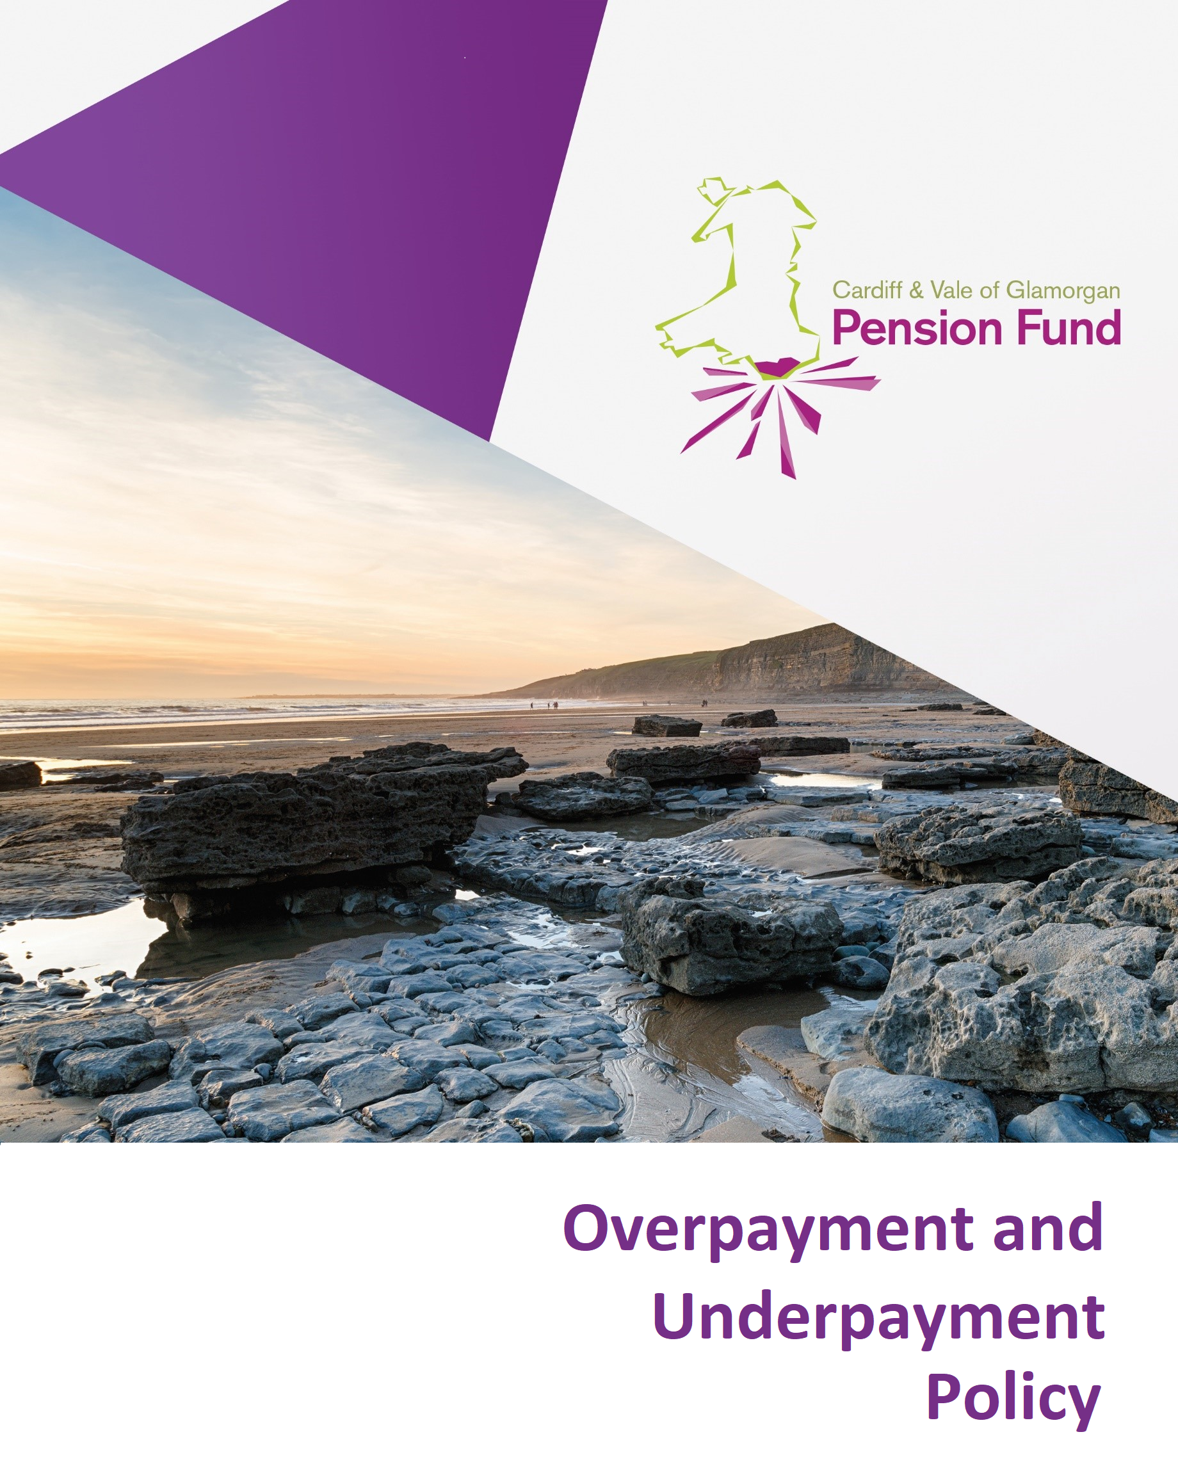

Contents

Introduction | 2
Policy objectives | 2
Purpose of the policy | 2
Effective date and reviews | 3
Scope | 3
Managing overpayments of pension on the death of a scheme member | 3
Managing overpayments of children’s pensions failing to cease at the appropriate time | 4
Managing overpayments of pension on incorrect information supplied by the employer in respect of the scheme member | 4
Managing overpayments of pension on incorrect rate of pension paid by the Fund and the member can reasonably be aware of the overpayment | 5
Managing overpayments of pension on incorrect rate of pension being paid by the Fund and the member cannot have known of the overpayment | 6
Discretion to write off overpayments | 6
Recovery | 7
Length of time to recover overpayments | 7
Claims of inability to repay overpayments | 7
Monitoring repayments | 7
Authority to write off overpayments | 8
Overpayments due to Fraud or Corruption | 8
Underpayments | 8
Prevention | 8
Policy Monitoring | 9

- Introduction

  - This is the Overpayment and Underpayment Pension Policy for Cardiff and Vale of Glamorgan Pension Fund, which is managed by Cardiff Council (the Administering Authority).

  - Overpayments of pension can occur for a variety of reasons. It is important that the Fund has a clear policy on how overpayments of pension are managed once they are identified.

  - Cardiff and Vale of Glamorgan Pension Fund (The Fund) recognises the need to take a pro-active approach to identifying any errors made administratively and also have robust controls in place to recognise potential fraudulent activity that could trigger overpayments.

Policy objectives

  - The policy objectives aim to ensure the Fund:

    - Has robust governance arrangements in place, to facilitate informed decision making, supported by appropriate advice, policies and strategies, whilst ensuring compliance with appropriate legislation and statutory guidance

    - Is managed in a fair and equitable manner, having regard to what is in the best interest of the Fund’s stakeholders, particularly the scheme members and employers

    - Delivers benefits to , and income is collected from, the right people at the right time in the right amount
    - Identifies errors as soon as possible

    - Rectifies overpayments with the cooperation of the individual

    - Encourages individuals to take an active role in checking payslips/payments for obvious errors; and

    - Avoids the need to escalate issues through the Internal Dispute Resolution Procedure (IDRP), where possible, by managing the process effectively

Purpose of the policy

  - The policy is designed to provide assurance to Fund members, Employer’s and other key Fund stakeholders that:

    - all overpayments are treated in a fair and equitable manner

    - due consideration has been taken to recover overpayments that have occurred but acknowledges that there may be legal reasons and/or other circumstances which mean that an overpayment may not, in practice, be able to be recovered (in whole or in part); and

    - steps are in place to prevent and also investigate potential fraudulent activity

Effective date and reviews

  - The policy was reviewed and became effective from 27 January 2020.

Scope

  - The policy applies to:

    - All members and former members, which in this policy includes survivor and pension credit members of the Cardiff and Vale of Glamorgan Pension Fund who have received one or more payments from that Fund;
    - Executors of the Estates of deceased Cardiff and Vale of Glamorgan Pension Fund members
    - Beneficiaries of Cardiff and Vale of Glamorgan Pension Fund members where those beneficiaries have received one or more payments from that Fund
    - Administrators of the scheme; and
    - The Pensions Committee

Type of overpayments

6.1 Managing overpayments of pension on the death of a scheme member

  - Understandably, notification of a death of a pensioner member of the scheme does not always happen immediately and as such it is not always possible to stop payment of the pension after a point in the payroll month and so an overpayment can occur

  - Should an overpayment of pension occur as a result of the death of a scheme member, the Fund will generally seek to recover overpayments that are greater than £100.00 (gross) in value unless there are legal reasons and/or other circumstances which mean that the overpayment may not, in practice, be able to be recovered (in whole or in part). A value of £100.00 or less in the instance of the death of a scheme member has been deemed by the Fund as uneconomical to pursue. In such circumstances, the Fund’s approach will be that the sum written off is treated as a liability against the scheme member’s former employer

  - All correspondence regarding an overpayment will be handled sensitively in the initial stages due to the circumstances surrounding how the overpayment has occurred

  - An invoice will be raised by the Fund to recover an overpayment which is greater than
£100.00 upon the death of a scheme member

6.2 Managing overpayments of children’s pensions failing to cease at the appropriate time

  - An eligible child as defined by the LGPS Regulations 2013, is entitled to receive a pension until such a time as their circumstances change and they are no longer eligible to receive a pension from the Fund

  - In these cases the individual in receipt of the pension is responsible for informing The Fund of a change in circumstances to ensure the pension is ceased at the appropriate time, failure to do so would result in an overpayment. Should an overpayment of pension occur as a result of late notification of change of circumstances, the Fund will generally seek to recover overpayments that are greater than

  - £100.00 (gross) in value unless there are legal reasons and/or other circumstances which mean that the overpayment may not, in practice, be able to be recovered (in whole or in part). A value of £100.00 or less has been deemed by the Fund as uneconomical to pursue. In such circumstances, the Fund’s approach will be that the sum written off is treated as a liability against the scheme member’s former employer

  - An invoice will be raised by the Fund to recover the overpayment which is greater than
£100.00 as a result of the late notification of the change in circumstances. The invoice will be sent to the individual whose bank account the child’s pension was being paid into

6.3 Managing overpayments of pension following incorrect information supplied by the employer in respect of the scheme member

  - Should an overpayment of pension occur as a result of inaccurate information provided by the scheme member’s employer on retirement, the Fund will generally seek to recover

  - monies that are greater than £100.00 in value unless there are legal reasons and/or other circumstances which mean that the overpayment may not, in practice, be able to be recovered (in whole or in part). A value of £100.00 (gross) or less has been deemed by the Fund uneconomical to pursue due to the administrative time involved

  - Overpayments that are greater than £100.00 in value will be recovered through the scheme member’s ongoing pension as this allows for the appropriate adjustment for tax. The pension will be reduced to the correct level for the next available monthly pension payment after a 4 week notice period. The scheme member will be notified in writing of the error and the course of action to be taken

  - Where there is no ongoing pension from which to deduct the overpaid amount, an invoice will be arranged by the Fund to recover the overpayment which is greater than £100.00 in value

6.4 Managing overpayments of pension as a result of the incorrect rate of pension paid by the Fund and the member can be said to be reasonably aware of the overpayment.

- There are a number of reasons why a pension could be paid at an incorrect higher rate. The most common reasons are detailed in the table below but it should be noted that this is not an exhaustive list

 | Type of overpayment | How overpayment has occurred
1 | Administration error upon creation of payroll record | Incorrect (overstated) rate of pension inputted onto payroll record but member informed in writing of the correct rate of pension to be paid.
2 | Entitlement to pension ceasing | Non notification that a child’s pension is no longer payable as the child aged 18 or above is no longer in full time education or vocational training.
3 | Entitlement to current rate of pension ceasing | A Pension Sharing Order or Earmarking Order being received after the implementation date meaning that the pension has been overpaid since that implementation date.
4 | Failure to action an alteration to the payroll record/reduction in pension | Failing to implement the change from the higher short term dependents pension to the lower long term rate.

If the scheme member has been notified of the correct rate of pension in writing and is receiving a higher amount, it can be said that the member can reasonably be aware that they are being over paid as the scheme member has been notified of the correct rate in writing.

6.5 The Fund will therefore generally seek to recover monies that are greater than £100.00 gross in value unless there are legal reasons and/or other circumstances which mean that the overpayment may not, in practice, be able to be recovered (in whole or in part). A value of £100.00 or less has been deemed by the Fund as uneconomical to pursue due to the administrative time involved.

6.6 The amount will be recovered from the scheme member’s ongoing pension as this allows for the appropriate adjustment for tax. The pension will also be reduced to the correct level for the next available monthly pension payment after a 4 week notice period, and will be notified in writing of the error and the course of action to be taken.

  - Where there is no ongoing pension from which to deduct the overpaid amount, an invoice will be arranged by the Fund to recover the overpayment which is greater than £100.00 in value.

Managing overpayments of pension following an incorrect rate of pension being paid by the Fund and it can be said that the member cannot have known of the overpayment

7.1 The table below illustrates how an overpayment of a member’s pension can occur without the member being aware. It should be noted that the table below is not an exhaustive list;

 | Type of overpayment | How overpayment has occurred
1 | Administration error upon calculation and notification of benefit entitlement (includes dependants’ pensions) | Incorrect (overstated) rate of pension inputted onto payroll record and member informed in writing of the, incorrect, rate of pension to be paid.
2 | Incorrect level of Guaranteed Minimum Pension (GMP) being paid | New information from HMRC leads to a revised rate of GMP to be used which, due to the different way cost of living increases are applied to GMP and the excess  over GMP, means that, overall, a lower level of pensions increase should have been paid.
3 | Pensions Increase | Pensions Increase inaccurately applied to the elements  of a pension in payment.

  - In circumstances where the overpayment had been a result of an error where the Pensioner could not have been aware of the error, we would notify the pensioner of the overpayment, pension payments would be corrected, however, the amount overpaid would not recovered.

Discretion to write off overpayments
  - For all scenarios mentioned above, Officers have the ability to exercise discretion in the event of legal reasons and/or exceptional circumstances and to ensure no individual is unfairly treated. If the pursuing recovery of an overpayment was to cause hardship and/or if there are legal reasons as to why the overpayment may not be recovered (in whole or in part) this would be taken into account as would the cost effectiveness of recovery. All applications made to write off of an overpayment will be investigated on a case by case basis and final decision will be made by the appropriate officer listed in section 16 dependent upon the amount potentially being written off. Overpayments where hardship has been established will be submitted for write off through the appropriate channels.

Recovery

  - The Limitation Act 1980 states that “An action founded on simple contract shall not be brought after the expiration of six years from the date on which the cause of action accrued”. However, section 32(1) of the Act effectively ‘postpones’ the date by which an administering authority may make a claim to recover monies in certain circumstances. It states “the period of limitation shall not begin to run until the plaintiff has discovered the fraud, concealment or mistake (as the case may be) or could with reasonable diligence have discovered it”. The potential effect of section 32(1) in relation to any overpayment and its recovery will be considered on a case-by-case basis.

  - Therefore the Fund will generally seek to recover overpayments that have been discovered within the last 6 years with the relevant postponement applied if applicable in line with the Limitation Act unless there are legal reasons and/or other circumstances which mean that the overpayment may not, in practice, be able to be recovered (in whole or in part).

  - Examples of limitation periods and how they operate in relation to overpayments are included in appendix 1 of this policy.

  - It should be borne in mind that where the Fund seeks to recover overpayments, there may be arguments raised as to why the overpayment should not be recovered (in whole or in part). These will need to be considered on a case-by-case basis and, if successful, may affect the ability of the Fund to recover the overpayment (in whole or in part).

Length of time to recover overpayment

  - The Fund will allow a pension overpayment to be recovered over the same amount of time as the overpayment occurred. For example, if overpayments were made for a 3 month period, the recovery period to repay the overpayment will be 3 months. In the event that reasonable arguments are advanced that the recovery period should be extended, the Fund can at its discretion allow an extension based on the individual’s circumstances; such an extension would generally not exceed a further 50% of the period in which the overpayment occurred with scope for this period to be extended based on the scheme member’s circumstances.

Claims of inability to repay overpayments

  - In cases where it is claimed that an overpayment cannot be repaid officers of the Fund will enter into negotiations with the scheme member/next of kin and an analysis of the cost effectiveness of pursuing the overpayment will be undertaken on a case-by-case basis. For large overpayments, where appropriate the Fund will seek legal advice. This approach will reduce the number of Internal Dispute Resolution Procedures applications and referrals to the Pensions Ombudsman. For any cases that do reach the Pensions Ombudsman, Cardiff and Vale of Glamorgan Pension Fund would have demonstrated engagement and negotiation with the complainant. For all overpayments where hardship has been proven all or part of the debt will be written off depending on individual circumstances.

Monitoring repayments

  - In cases where recovery is not being made through the payroll and an invoice has been raised, the responsibility for chasing the payment rests with the Council’s Debt Recovery Team. If a final reminder is issued, officers are notified and a decision is made by the Pensions Manager and Principal Pensions Officer to decide whether to take legal action, taking into consideration the amount and circumstances against the potential of legal action.

Authority to write off overpayments

  - In line with the Council’s Scheme of Delegation, the Fund will apply the following levels of authority when writing off overpayments:

Total value of overpayment | Authority to write off overpayment
No more than £100.00 (gross) on death of a pensioner  No more than £100.00 (gross) on any other overpayment type | Automatic write off
Up to no more than £5,000.00 (gross) | Pensions Manager
Up to no more than £10,000.00 | Revenue Services Manager
£10,000.00+ (gross) | Cardiff Council Section 151 Officer

Overpayments due to Fraud or Corruption

On rare occasions members' benefits may be overpaid due to:
- Fraud by the member or their estate
- Fraud by the employer
- Fraud by a pensions officer
- Other criminal activity such as blackmail or corruption
Where an overpayment is discovered to have been made due to fraud or any other criminal act, the pension will be suspended and an attempt will be made to recover the overpayment of pension and lump sum immediately.

Cardiff Council will involve internal audit in such cases and the settlement of overpayments may be resolved by the Courts of Law.

Underpayments

  - Should an underpayment to pension occur, any underpayment of pension will be rectified in the next available pay period after underpayment has been identified.

15.2 Interest will be paid on the underpaid amount(s) in line with LGPS Regulations. Interest will be paid on pension payments which are more than 1 year late, and on lump sum payments which are more than 1 month late. Interest payable is calculated at one per cent above base rate on a day to day basis from the due date of payment and compounded on a three-monthly basis.

Prevention

  - The Fund has in place processes in order to minimise the risk of overpayments occurring.

  - The National Fraud Initiative is conducted every two years; it compares files of pensioners with the Department for Work and Pensions database of the deceased and highlights matches for investigation. Cardiff and Vale of Glamorgan Pension Fund actively participates in this initiative.

  - Cardiff and Vale of Glamorgan Pension Fund participates in overseas life existence checks to ensure only legitimate pensions are being paid and to reduce the likelihood of fraudulent activity. Mortality screening checks are carried out on a monthly basis through Atmos. Monthly notifications are received from Tell Us Once (a government service that allows you to easily tell several departments in one go that someone’s died. The service is provided by most local authorities on behalf of the Department for Work and Pensions)

  - A report is run periodically on the pension administration system to identify individuals in receipt of a child’s pension, further investigations are then carried out for children that are identified as over the age of 18 to ensure they are still entitled to receive a pension.

  - Cardiff and Vale of Glamorgan Pension Fund includes reminders in its correspondence that the Fund must be advised of changes in circumstances or the death of a scheme member. If a payslip is returned to the Payroll Team they carry on making payments but stop all correspondence to that address. If money is returned by the bank Payroll will send a letter to the home address to investigate.

  - Fund officers have a robust system in place for identifying changes to the payroll that need to be processed for a particular payroll month. The process incorporates payroll deadlines and ensures changes are made in a correct and timely manner. This would be in circumstances such as a change from a short term dependant’s pension to a long term pension.
- Policy Monitoring

19.1 This policy will be reviewed formally on an annual basis, but can be reviewed more frequently and amended if appropriate at the request of the Pensions Committee.

