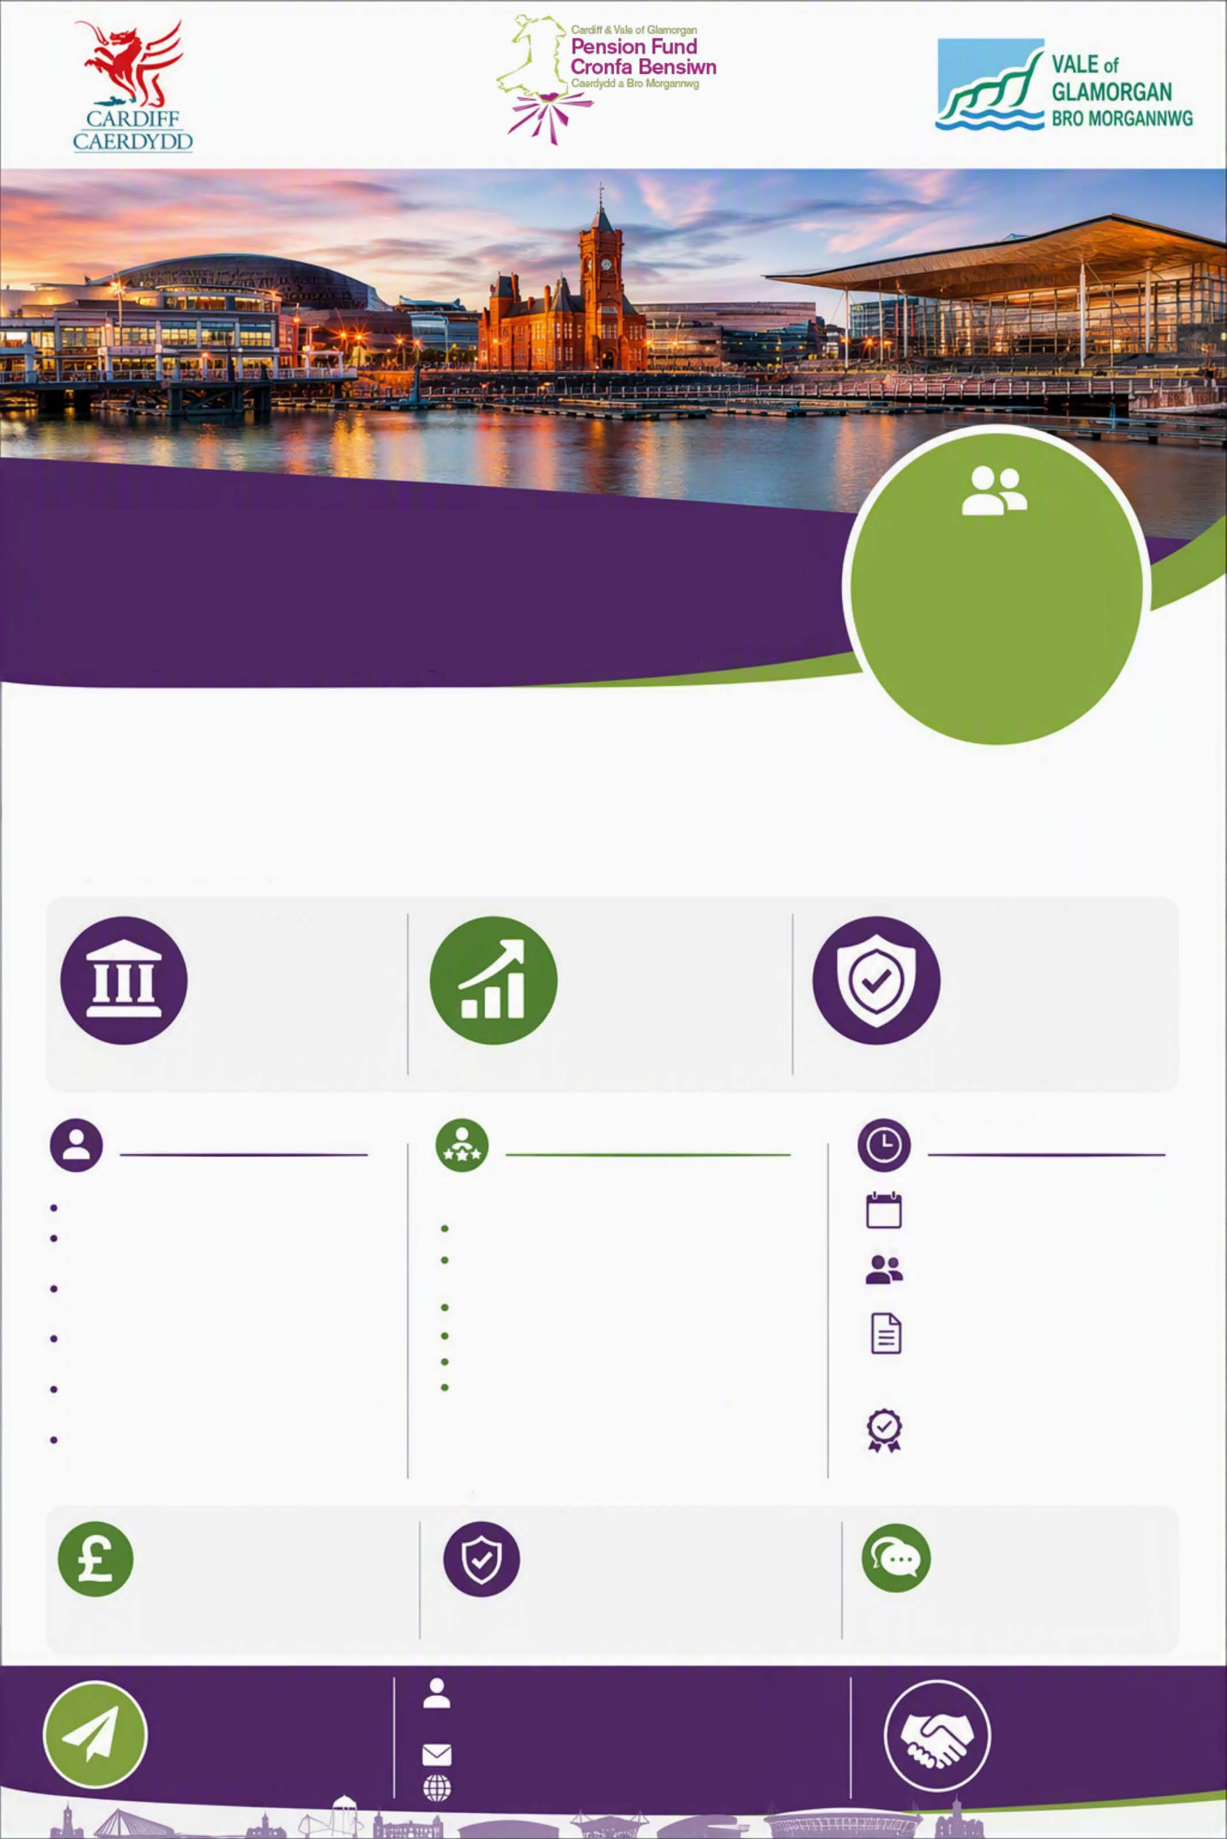
Independent
Professional
Trusted
www.cardiffandvalepensionfund.org.uk
pensions@cardiff.gov.uk
Jayne Newton
Communications Officer
Cardiff & Vale of Glamorgan Pension Fund
APPLY NOW

Help shape the future.
Make an impact.
INTERESTED?

For an informal discussion or further information please get in touch.
INDEPENDENCE

The Independent Person must be able to demonstrate independence from the Fund’s advisers, contractors and service providers.
Conflicts of interest must be declared.
REMUNERATION

Competitive remuneration will be provided, reflecting the responsibilities of the role and relevant experience.
Reasonable expenses will be reimbursed.
Includes committee meetings, training, review of papers, officer engagement and ad-hoc support
Approximately 12 days per year
You will have the confidence and credibility to provide constructive challenge, sound judgement and impartial advice in a complex environment.
Investment management and oversight
Risk management
Significant senior-level experience in the following areas:
Support delivery of the Fund’s strategic objectives
Contribute to effective decision-making and continuous improvement
Provide independent professional insight and assurance
Support oversight of investment, funding and administration
Review and challenge reports, advice and recommendations
Attend Pension Fund Committee meetings
Public sector finance
Funding and actuarial matters
Pension administration
LGPS governance
Initial 3-year appointment subject to review
A combination of virtual and in-person meetings
As Independent Person you will:
COMMITMENT
WE ARE LOOKING FOR
THE ROLE
INDEPENDENT CHALLENGE

Provide objective insight and assurance to support effective decision-making and continuous improvement.
INVESTMENT OVERSIGHT

Support oversight of investment, funding and risk to promote long-term value for members.
GOVERNANCE

Strengthen governance and accountability through independent advice and challenge.
The Cardiff & Vale of Glamorgan Pension Fund is seeking to appoint an experienced and independent professional as its Independent Person.

You will provide objective challenge, scrutiny and professional insight to support the Pension Fund Committee and officers, helping to ensure robust, transparent and well-governed decision-making on behalf of 48,000 scheme members and participating employers.
Make a
real difference
Support strong governance and safeguard the pensions of thousands of local government employees, pensioners and deferred members across the fund.
Help shape the future of local government pensions
CARDIFF & VALE OF GLAMORGAN PENSION FUND

INDEPENDENT PERSON

